Jason, 1C, Cephalopod Image Classification Model

First of all, I created a form to calculate the performances for humans when they classify cephalopods. The average accuracies per cephalopod can be found below. This performance will be used as a basis for what our model should improve upon.

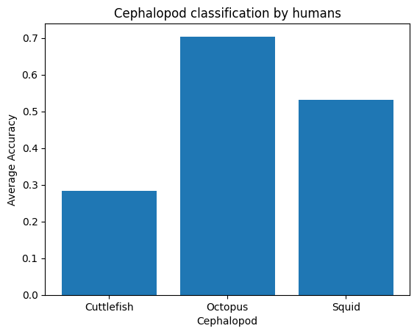

After this, I created a model with not much depth, to also use it as a baseline for what a model with more depth should improve upon too. In the scores below you can see that the performances weren’t amazing and had a lot of overfitting.

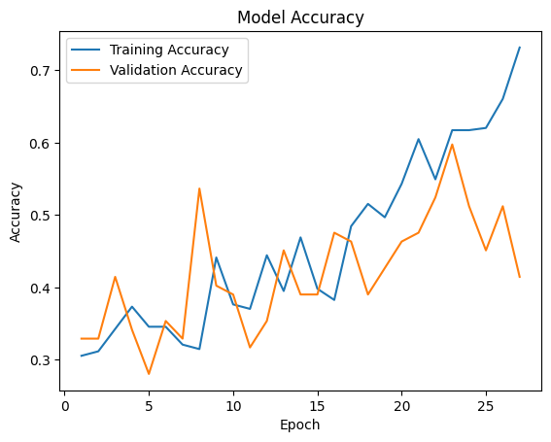

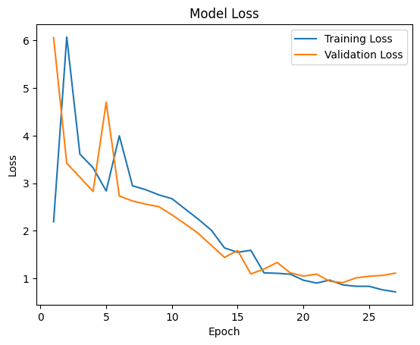

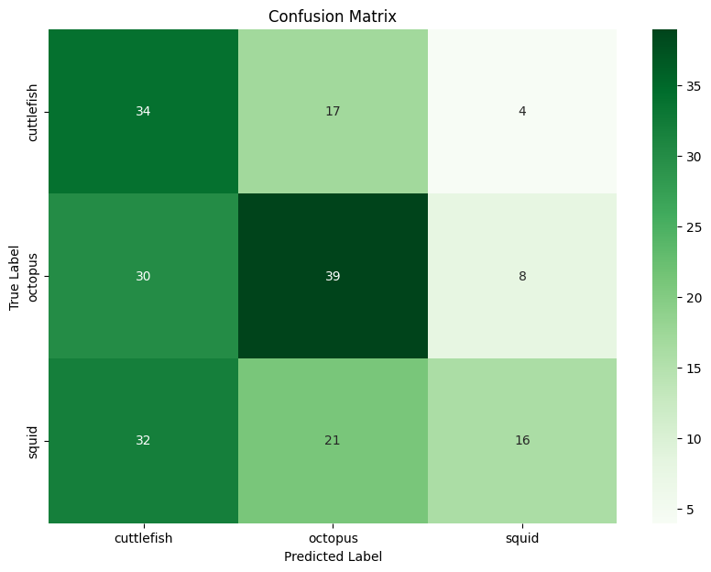

After this, I created multiple versions of the model: the first one didn’t have much preprocessing and also didn’t have too much depth. This model improved just slightly better than the first model with barely any depth. After this I created a model, which got generated images for training data. This data would be generated to be flipped, rotated, have a different brightness, etc. This model also improved slightly better than the past model, so I created a new model. The third model trains on the normal dataset while also using a pre-trained model. The performances for this went up towards 85% without much overfitting. I eventually came to the final model, which had the second and third model’s techniques combined, which I will show below.

First I apply data augmentation:

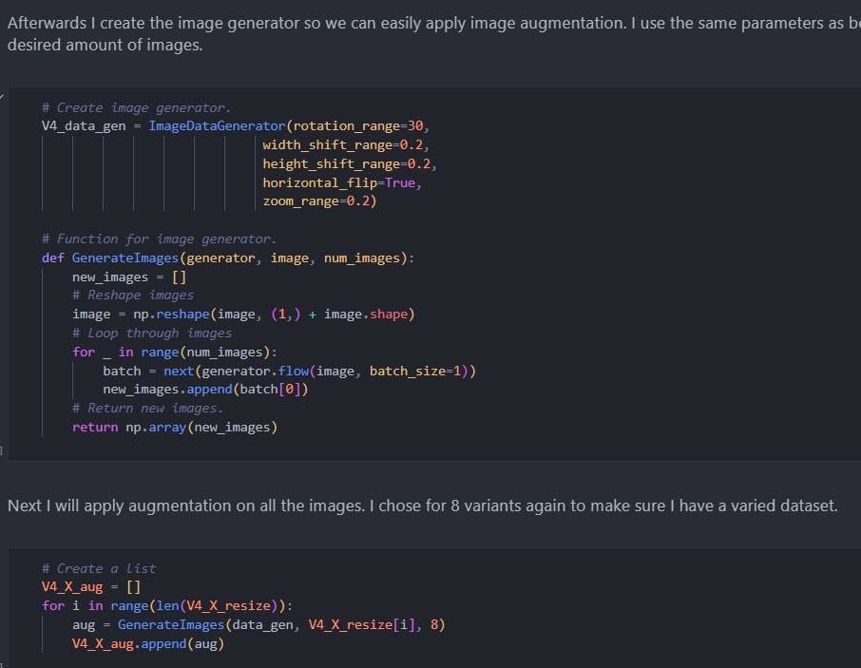

This will result in below images being generated:

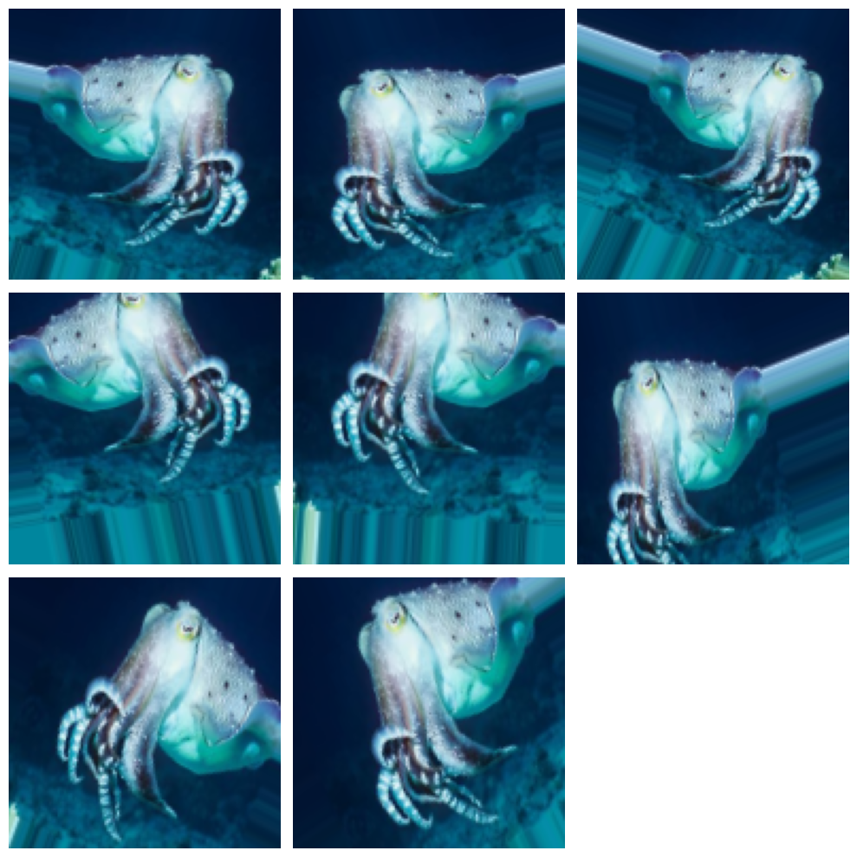

After this, I split the dataset into training and testing data:

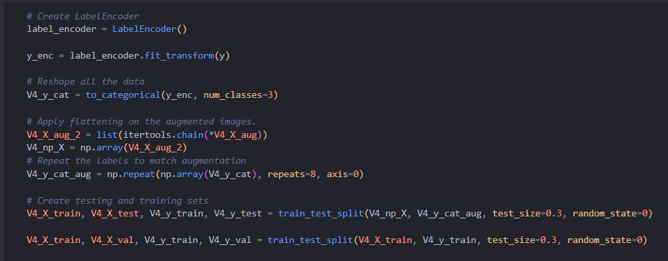

Now to finally train the model, I would first have to get the pre-trained model:

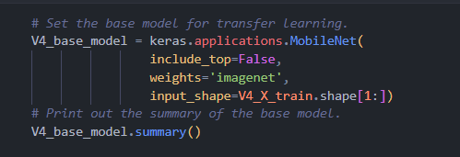

After this I create the model’s structure:

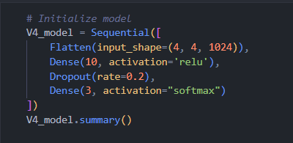

And eventually, I will use the pre-trained model to look for certain important features in the images and then compile the model:

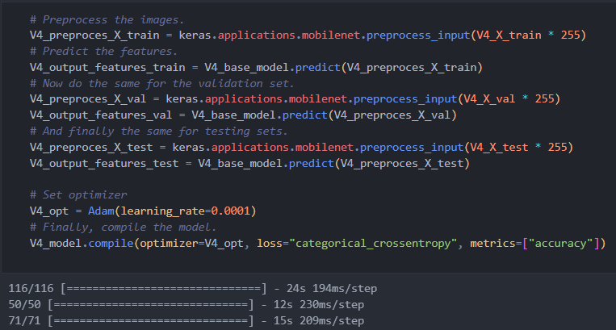

After this, I train the model using EarlyStopping, which will stop the model from training when no more improvements are made in the performances



And eventually, we can see the performances for this model, which now has less overfitting and a much better accuracy:

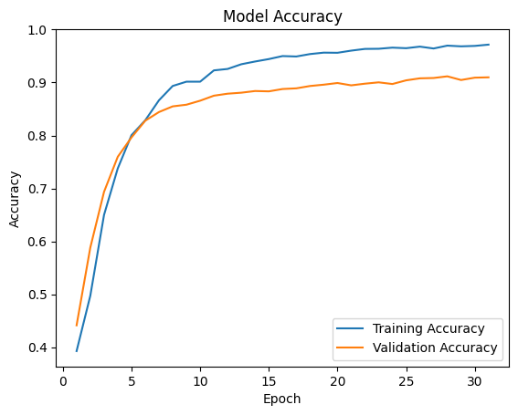

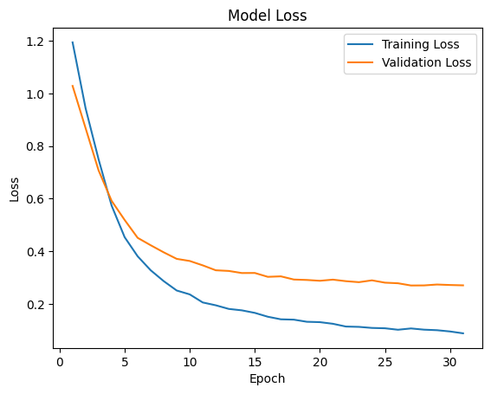

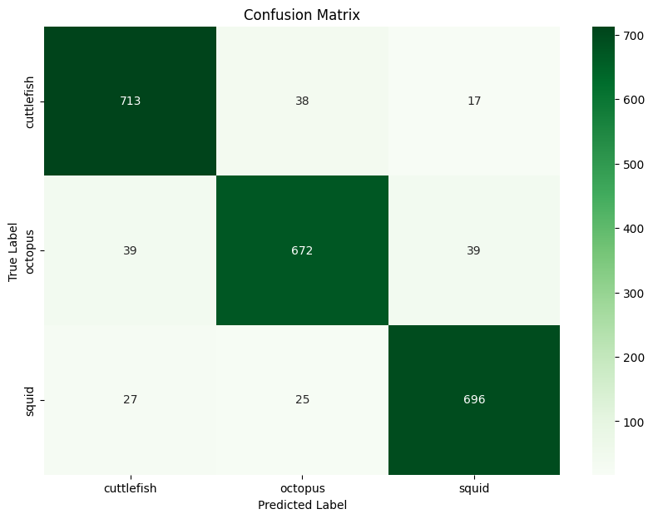

Finally, we evaluate why the model made certain errors, in the error analysis phase:

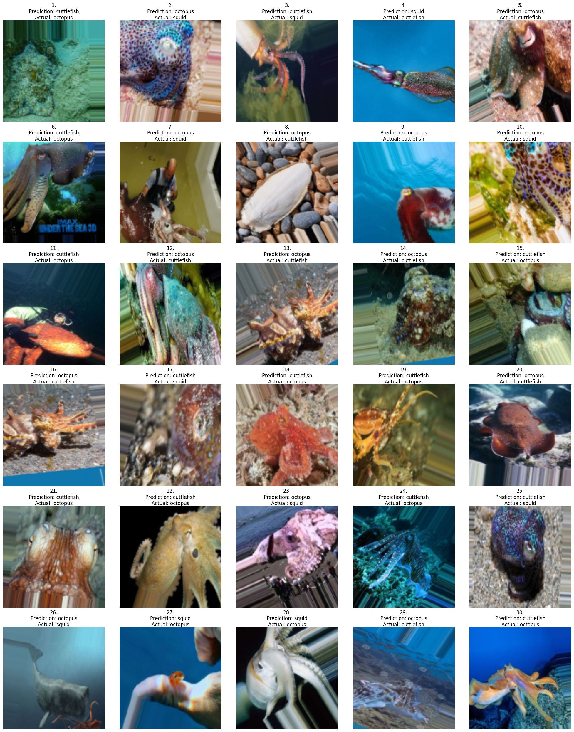

In this phase, I evaluate why the model made the wrong predictions, which could be due to mislabeling, similarities between species, or just images on which the subject is hard to find.